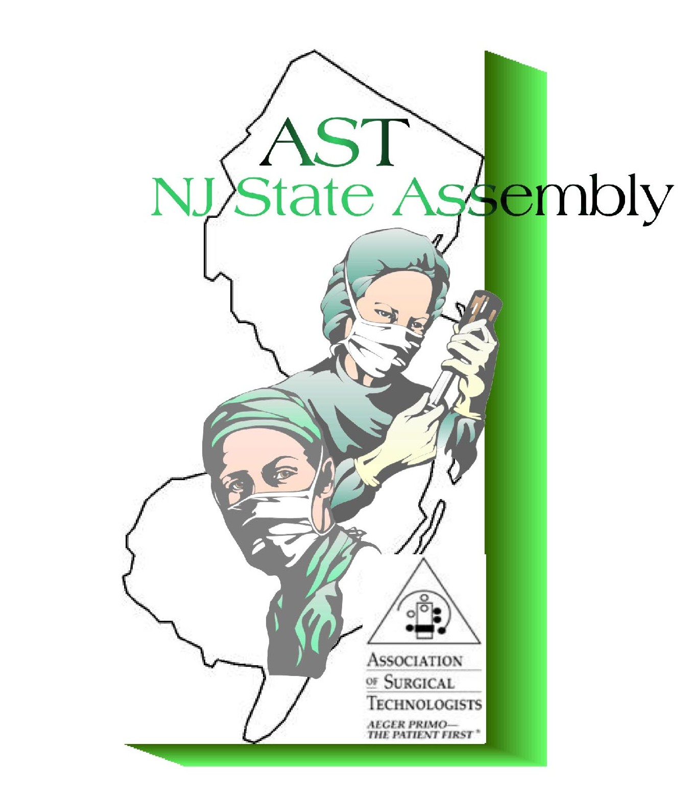Registration Form for NJ-AST State Assembly

**2018 Spring Workshop with Business Meeting – Earn 5 CEUs**

Berkeley College – 44 Rifle Camp Rd – Woodland Park, NJ 07424

April 21st, 2018 – 9:00am – 4:00pm

(registration begins at 8am)

AST Membership Number - __________________________ NBSTSA Certification Number- ____________________________

***Please be sure to bring AST and CST card with you for confirmation and proper crediting!*** NAME - _____________________________________________________

___CST ___ST ___Student ___Other* ________

PLEASE SPECIFY

ADDRESS - _________________________________________________________________ Street

_________________________________________________________________ City State Zip PHONE NUMBER - _______________________________- Day _______________________________ - Evening EMAIL ADDRESS - ___________________________________________________________

Employer / School Name - _______________________________________________________________

**Registration Fees:**Pre-Registration -$50.00

Door Registration - $60.00

Pre-Registration (Students) - $20.00

Door Registration (Students) -$25.00* Students, please bring student ID for verification. *Please make check or money order payable to:**NJ-AST State AssemblyMail registration form with payment to:PO Box 404, Iselin, NJ 08830** Email address may be used for NJ-AST contact/updates/notifications.*OTHER - May include but not limited to CFA's, surgical assistants, LPN/LVN/RN, CST/CFA's with alt credentialing.

Please check with your appropriate group for CEU acceptance. **WE ARE AN AST APPROVED CEU PROVIDER!!!**

**NJAST’s objectives for this workshop are to study techniques related to**

**surgical procedures in multiple surgical areas.**

Topics subject to change without notice. NJAST assumes no liability for these unavoidable changes.

As stated on the website, registration and attendance to the conference/workshop grants permission to take and use pictures

for the NJAST website and other NJAST related functions. Please advise in writing if you do not wish your picture taken.

**Questions? Please email Jeanne Rosko at jrace5@aol.com**